Experiment – 10

AIM
To study the architecture and instruction set of 8085 Microprocessor.

PLATFORM/TOOL USED
- Simulator: https://circuitverse.org/simulator

THEORY
The microprocessor is the CPU (Central Processing Unit) of a computer. It is the heart of the computer. Here, we will describe Intel 8085 as it is one of the most popular 8-bit microprocessor.

8085 is pronounced as "eighty-eighty-five" microprocessor. It is an 8-bit microprocessor designed by Intel in 1977 using NMOS technology.
The size of the data bus of 8085 is 8 bits while that of the address bus is 16. Therefore, can address 64 KB (i.e., 216) memory. Also, as it can perform 8-bit operation thus the size of ALU is also 8-bit.

- Architecture of 8085 microprocessor
The architecture of 8085 microprocessor provides the idea about what are the operations to be executed and how these are performed.

8085 consists of the following functional units −
- Accumulator
It is an 8-bit register used to perform arithmetic, logical, I/O & LOAD/STORE operations. It is connected to internal data bus & ALU.
- Arithmetic and logic unit
As the name suggests, it performs arithmetic and logical operations like Addition, Subtraction, AND, OR, etc. on 8-bit data.
- General purpose register
There are 6 general purpose registers in 8085 processor, i.e., B, C, D, E, H & L. Each register can hold 8-bit data.
These registers can work in pair to hold 16-bit data and their pairing combination is like B-C, D-E & H-L.
- Program counter
It is a 16-bit register used to store the memory address location of the next instruction to be executed. Microprocessor increments the program whenever an instruction is being executed, so that the program counter points to the memory address of the next instruction that is going to be executed.
- Stack pointer
It is also a 16-bit register works like stack, which is always incremented/decremented by 2 during push & pop operations.
- Temporary register
an 8-bit register, which holds the temporary data of arithmetic and logical operations.
- Flag register
It is an 8-bit register having five 1-bit flip-flops, which holds either 0 or 1 depending upon the result stored in the accumulator.
These are the set of 5 flip-flops −
- Sign (S)
- Zero (Z)
- Auxiliary Carry (AC)
- Parity (P)
- Carry (C)
Its bit position is shown in the following table −
D7 | D6 | D5 | D4 | D3 | D2 | D1 | D0
S | Z |  | AC |  | P |  | CY
- Instruction registers and decoder
It is an 8-bit register. When an instruction is fetched from memory then it is stored in the Instruction register. Instruction decoder decodes the information present in the Instruction register.
- Timing and control unit
It provides timing and control signal to the microprocessor to perform operations. Following are the timing and control signals, which control external and internal circuits −
- Control Signals: READY, RD’, WR’, ALE
- Status Signals: S0, S1, IO/M’
- DMA Signals: HOLD, HLDA
- RESET Signals: RESET IN, RESET OUT
- Interrupt control
As the name suggests it controls the interrupts during a process. When a microprocessor is executing a main program and whenever an interrupt occurs, the microprocessor shifts the control from the main program to process the incoming request. After the request is completed, the control goes back to the main program.
There are 5 interrupt signals in 8085 microprocessors: INTR, RST 7.5, RST 6.5, RST 5.5, TRAP.
- Serial Input/output control
It controls the serial data communication by using these two instructions: SID (Serial input data) and SOD (Serial output data).
- Address buffer and address-data buffer
The content stored in the stack pointer and program counter is loaded into the address buffer and address-data buffer to communicate with the CPU. The memory and I/O chips are connected to these buses; the CPU can exchange the desired data with the memory and I/O chips.
- Address bus and data bus
Data bus carries the data to be stored. It is bidirectional, whereas address bus carries the location to where it should be stored, and it is unidirectional. It is used to transfer the data & Address I/O devices.

Hardware Architecture of 8085 Microprocessor
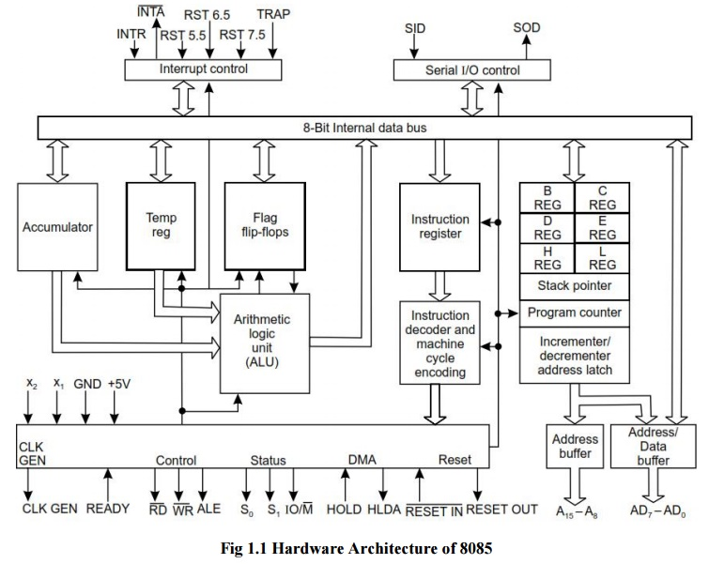
- Instruction Set of 8085
- An instruction is a binary pattern designed inside a microprocessor to perform a specific function.
- The entire group of instructions that a microprocessor supports is called Instruction Set.
- 8085 has 246 instructions.
- Each instruction is represented by an 8-bit binary value.
- These 8-bits of binary value is called Opcode or Instruction Byte.

Classification of Instruction Set
- Data Transfer Instruction
- Arithmetic Instructions
- Logical Instructions
- Branching Instructions
- Control Instructions

Data Transfer Instructions
- These instructions move data between registers, or between memory and registers.
- These instructions copy data from source to destination.
- While copying, the contents of source are not modified.

Opcode | Operand | Description | Example
MOV | Rd, Rs  Rd, M  M, Rs | Copy from source to destination. | MOV B, C  MOV B, M  MOV M, C
MOV | Rd, Rs  Rd, M  M, Rs | Copy from source to destination. | MVI A, 57H  MVI M, 57H
LXI | Reg. pair, 16-bit  data | Load register pair immediate | LXI H, 2034 H
LDA | 16-bit address | Load Accumulator | LDA 2034H
LDAX | B/D Register Pair | Load accumulator indirect | LDAX B
LHLD | 16-bit address | Load H-L registers direct | LHLD 2040 H
STA | 16-bit address | Store accumulator direct | STA 2500 H
STAX | Reg. pair | Store accumulator indirect | STAX B
SHLD | 16-bit address | Store H-L registers direct | SHLD 2550 H
XCHG | None | Exchange H-L with D-E | XCHG

Arithmetic Instructions
- These instructions perform the operations like:
- Addition
- Subtract
- Increment
- Decrement

Opcode | Operand | Description | Example
ADD | R  M | Add register or memory to accumulator | ADD B  ADD M
ADC | R  M | Add register or memory to accumulator with  carry | ADC B  ADC M
ADI | 8-bit data | Add immediate to accumulator | ADI 45 H
ACI | 8-bit data | Add immediate to accumulator with carry | ACI 45 H
DAD | Reg. pair | Add register pair to H-L pair | DAD B
SUB | R  M | Subtract register or memory from accumulator | SUB B  SUB M
SBB | R  M | Subtract register or memory from accumulator with borrow | SBB B  SBB M
SUI | 8-bit data | Subtract immediate from accumulator | SUI 45 H
SBI | 8-bit data | Subtract immediate from accumulator with borrow | SBI 45 H
INR | R  M | Increment register or memory by 1 | INR B  INR M
INX | R | Increment register pair by 1 | INX H
DCR | R  M | Decrement register or memory by 1 | DCR B  DCR M
DCX | R | Decrement register pair by 1 | DCX H

Logical Instructions
- These instructions perform logical operations on data stored in registers, memory and status flags.
- The logical operations are:
- AND
- OR
- XOR
- Rotate
- Compare
- Complement

Opcode | Operand | Description | Example
CMP | R  M | Compare register or memory with accumulator | CMP B  CMP M
CPI | 8-bit data | Compare immediate with accumulator | CPI 89H
ANA | R  M | Logical AND register or memory with accumulator | ANA B  ANA M
ANI | 8-bit data | Logical AND immediate with accumulator | ANI 86H
XRA | R  M | Exclusive OR register or memory with accumulator | XRA B  XRA M
ORA | R  M | Logical OR register or memory with accumulator | ORA B  ORA M
ORI | 8-bit data | Logical OR immediate with accumulator | ORI 86H
XRA | R  M | Logical XOR register or memory with accumulator | XRA B  XRA M
XRI | 8-bit data | XOR immediate with accumulator | XRI 86H
RLC | None | Rotate accumulator left | RLC
RRC | None | Rotate accumulator right | RRC
RAL | None | Rotate accumulator left through carry | RAL
RAR | None | Rotate accumulator right through carry | RAR
CMA | None | Complement accumulator | CMA
CMC | None | Complement carry | CMC
STC | None | Set carry | STC

Branching Instructions
- The branching instruction alter the normal sequential flow.
- These instructions alter either unconditionally or conditionally.

Opcode | Operand | Description | Example
JMP | 16-bit address | Jump unconditionally | JMP 2034 H
Jx | 16-bit address | Jump conditionally | JZ 2034 H
CALL | 16-bit address | Call unconditionally | CALL 2034 H
Cx | 16-bit address | Call conditionally | CZ 2034 H
RET | None | Return unconditionally | RET
Rx | None | Call conditionally | RZ
RST | 0 – 7 | Restart (Software Interrupts) | RST 3

Control Instructions
- The control instructions control the operation of microprocessor.

Opcode | Operand | Description | Example
NOP | None | No operation | NOP
HLT | None | Halt | HLT
DI | None | Disable interrupt | DI
EI | None | Enable interrupt | EI
RIM | None | Read Interrupt Mask | RIM
SIM | None | Set Interrupt Mask | SIM

RESULT
The architecture and instruction set of 8085 Microprocessor been studied and analysed.

Criteria | Total Marks | Marks Obtained | Comments
Concept (A) | 2
Implementation (B) | 2
Performance (C) | 2
Total | 6

